# Numeric Computing Java Lab

## Loan repayment schedule

Create a loan class using the following UML diagram:

|  |
| --- |
| Loan |
| private double loanAmount  private double rate  private double monthlyInstallment |
| public Loan(double loanAmountValue, double rateValue, double monthlyInstallmentValue)  public double getLoanAmount( )  public double getRate()  public double getMonthlyInstallment()  public void setLoanAmount(double loanAmountValue)  public void setRate(double rateValue)  public void setMonthlyInstallment(double monthlyInstallmentValue)  public void printLoanRepaymentSchedule() |

Please submit .java file (Do not submit. Rar or zip file) Below is given the sample output. You can refer to power point *loan repayment* for math help.

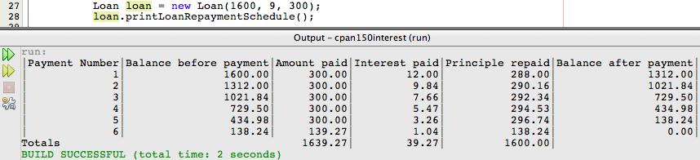

## Grading standard

20/20 - Work so amazing the instructor would only see this once in a lifetime

18/20 – Exceptional work, rare

16/20 - Great work, student has full command of the topic.

13/20 - Minor errors

10/20 - Errors and perhaps a major error

8/20 - Regular and consistent major errors. Lack of understanding

4/20 - Largely empty